

A MINI-PROJECT REPORT

ON

“XAI Intrusion Detection System”
BY

- Atharv Patil 641
- Rudra Pawar 644
- Darshan Pawar 643
- Amish Koli 628

Under the guidance of

Prof. Samrin Pabrekar

Juhu-Versova Link Road Versova, Andheri(W), Mumbai-53 Department of Artificial Intelligence & Data Science
University of Mumbai May- 2026

Juhu-Versova Link Road Versova, Andheri(W), Mumbai-53

C E R T I F I C A T E
Department of Artificial Intelligence & Data Science
This is to certify that
- Atharv Patil
- Rudra Pawar
- Darshan Pawar
- Amish Koli
Have satisfactorily completed this project entitled

“XAI Intrusion Detection System”

Towards the partial fulfilment of the
THIRD YEAR BACHELOR OF ENGINEERING IN
(ARTIFICIAL INTELLIGENCE & DATA SCIENCE)
as laid by University of Mumbai.

Guide
Prof. Samrin Pabrekar
H.O.D.
Dr. Jyoti Deshmukh




Principal
Dr. Sanjay Bokade


Project Report Approval for T. E.

This project report entitled “XAI Intrusion Detection System” by Amish Koli 628, Atharv Patil 641, Rudra Pawar 644, Darshan Pawar 643 is approved for the degree of Third-Year Bachelor of Artificial Intelligence and Data Science.

Examiners: 1
2

Date: Place:

Declaration

We wish to state that the work embodied in this project titled “XAI Intrusion Detection System” forms our own contribution to the work carried out under the guidance of “Prof. Samrin Pabrekar” at the Rajiv Gandhi Institute of Technology.
I declare that this written submission represents my ideas in my own words and where others’ ideas or words have been included, I have adequately cited and referenced the original sources. I also declare that I have adhered to all principles of academic honesty and integrity and have not misrepresented or fabricated or falsified any idea source in my submission. I understand that any violation of the above will be cause for disciplinary action by the Institute and can also evoke penal action from the sources which have thus not been properly cited or from whom proper permission has not been taken when needed.

Atharv Patil T-641

Rudra Pawar T-644

Darshan Pawar T-643

Amish Koli T-628

Abstract
The project titled “Explainable AI-Based Intrusion Detection System” focuses on developing an intelligent and transparent cybersecurity solution capable of detecting and analyzing malicious network activities in real time. With the rapid expansion of digital infrastructure and internet-based services, cyber threats such as denial-of-service attacks, brute force attempts, and network intrusions have become increasingly sophisticated and frequent. Traditional intrusion detection systems (IDS) often lack interpretability, making it difficult for security analysts to understand the reasoning behind model predictions and reducing trust in automated systems.
To overcome these limitations, the proposed system integrates Explainable Artificial Intelligence (XAI) techniques into intrusion detection, enhancing transparency, trust, and decision-making capabilities. The system is implemented as a Flask-based backend application using Python, which handles data preprocessing, model execution, and real-time detection. The frontend is developed using HTML, CSS, and JavaScript to provide an interactive dashboard for visualizing alerts, predictions, and explanation outputs in a user-friendly manner. The system utilizes benchmark datasets such as NSL-KDD and CICIDS for training and evaluation, ensuring robustness across various types of network attacks.

The architecture of the system is modular and consists of multiple core components. A key component is the feature adapter module, which standardizes and transforms input data into a consistent format compatible with trained models, thereby eliminating feature mismatch issues between different datasets. The machine learning layer includes a Random Forest classifier for multi-class attack classification and an Isolation Forest model for anomaly detection. These models work collaboratively to generate a combined risk score, providing a more reliable and comprehensive assessment of potential threats.
Furthermore, an explainability module powered by SHAP (Shapley Additive Explanations) is integrated to interpret model predictions. This enables users to understand which features contribute most significantly to a detected intrusion, thereby improving transparency and trust in the system. Each module is organized into structured directories, including preprocessing, model training, anomaly detection, explainability, and real-time detection, ensuring maintainability and scalability.

The real-time detection component simulates live network traffic using virtual machine logs and continuously processes incoming data to generate instant predictions. The results are displayed on a dashboard that provides clear visualization of intrusion alerts, risk scores, and feature-level explanations. Overall, the proposed system not only improves detection accuracy but also emphasizes interpretability, usability, and scalability, making it a robust and practical solution for modern cybersecurity challenges.

Keywords:

Explainable Artificial Intelligence (XAI), Intrusion Detection System (IDS), Machine Learning, Random Forest, Isolation Forest, Network Security, NSL-KDD Dataset, CICIDS Dataset, SHAP (Shapley Additive Explanations), Real-Time Detection, Cybersecurity Analytics

Contents

Abstract |  | i
Content |  | ii
List of Figures |  | iii
List of Tables |  | iv
1 | Introduction  - Introduction  Description...……………………………………  - Organization of Report……………………………………………. | 1  1  1
2 | Literature Review | 2  2  3  3
2.1 System Existing System……………………………………….
2.2 Research gap……………………………………………………
 | 2.3 Problem Statement and Objective…………………………………
 | 2.4 Scope ………………………………………………………
3 | Proposed System | 4  4  4  5  5  6
 | 3.1 Framework and Algorithm………
 | 3.2 Details of Software…………………
 | 3.2.1 Software Requirement……………………………………….
 | 3.3 Design Details…………………………………………
3.3.1 System Architecture…….
3.4 Methodology (Your methodology to solve problem) ….
4 | Implementation  4.1 Results…………………………………. | 9
5 | Conclusion and Future Work | 15
 | References | 16

LIST OF FIGURES

Figure  No. | Name | Page no.
3.3 | System Architecture | 6
4.1 | Execution of DoS attack using hping3 tool | 10
4.2 | Detection of Dos attack | 11
4.3 | Nmap port scanning | 12
4.4 | Detection of probe/scan attack | 12
4.5 | Dashboard illustrating real-time risk score timeline and activity logs | 13
4.6 | Demonstrating Hydra-based brute-force attack | 13
4.7 | Dashboard illustrating detection of brute-force attack | 14

LIST OF TABLES

Table No. | Name | Page no.
2.2 | Limitations | 2
3.1 | System Framework | 4

CHAPTER 1

Introduction

Introduction Description
The security of network systems has become a major concern with the rise of advanced cyberattacks capable of exploiting vulnerabilities and disrupting digital infrastructure. Such malicious activities can compromise data integrity, confidentiality, and system reliability, making intrusion detection an important research challenge in the modern cybersecurity landscape.

The Explainable AI-Based Intrusion Detection System addresses this issue by integrating machine learning and anomaly detection techniques to identify and analyze suspicious network traffic. The system comprises three modules—intrusion detection, anomaly detection, and explainability analysis which work together to ensure accurate and reliable threat identification. Developed as a Flask-based web application, the project features a user-friendly interface built using HTML, CSS, and JavaScript, allowing users to monitor network activity and view detection results. The backend, implemented in Python and Flask, handles data processing, routing, and model execution.

By combining AI-driven detection with explainable insights, the system provides a reliable and transparent approach to identifying cyber threats, improving interpretability, and supporting the development of a more secure and trustworthy network environment.

Organization of report

Chapter 2: Literature Review – Discusses existing techniques for intrusion detection, anomaly detection, and network security analysis. It identifies current limitations and establishes the need for the proposed explainable AI-based system.

Chapter 3: System Design and Methodology – Describes the framework, architecture, and working of the proposed system, including module design, workflow diagrams, and algorithms used for intrusion detection.

Chapter 4: Implementation and Results – Presents the development details of the system using Flask, Python, and machine learning models. It includes data preprocessing, model integration, frontend design, and screenshots of the working application. Highlights the output of various modules, evaluates system performance, and compares results with existing intrusion detection approaches.

Chapter 5: Conclusion and Future Outlook – Summarizes key findings and suggests future enhancements such as advanced deep learning models and improved real-time detection capabilities.

CHAPTER 2

Literature Review

Survey existing system
    - A Random Forest-based intrusion detection model trained on NSL-KDD dataset shows strong classification performance in identifying normal and attack traffic.
    - Anomaly detection techniques such as Isolation Forest detect unusual network behavior and unknown attack patterns beyond signature-based methods.
    - Feature engineering and preprocessing, including encoding and normalization, help handle high- dimensional data and improve model accuracy.
    - Explainable Artificial Intelligence (XAI) techniques such as SHAP provide insights into model predictions and enhance transparency.
    - Hybrid systems combining classification and anomaly detection models achieve better accuracy and stable performance.
    - Real-time intrusion detection using continuous monitoring and log analysis enables faster threat identification and improved responsiveness.

Limitation existing system or Research gap
Table 2.2 highlights the limitations of existing intrusion detection systems. It outlines challenges such as poor detection of unknown attacks, high false positive rates, and lack of explainability in AI-based models. These drawbacks emphasize the need for an integrated, explainable, and scalable system capable of accurately detecting network intrusions, analyzing anomalies, and providing clear insights within a unified platform.

Table 2.2 Limitations

Existing System | Limitations
Signature-based Intrusion Detection  Systems | Perform well on known attack patterns but fail to detect new or unknown threats in real-world environments.
Anomaly Detection Models | Require high computational resources and may produce false positives; not always suitable for real-time detection.
Existing Security Monitoring Tools | Often focus only on alert generation and lack integration of explainable AI for understanding detection results.
Traditional Rule-based Systems | Detect only predefined attacks; ineffective against advanced and evolving cyber threats.

Problem Statement and Objectives
Existing network systems lack reliable mechanisms to detect advanced cyberattacks and anomalous activities in real-time. Security analysts often struggle to identify unknown threats due to the limitations of traditional intrusion detection systems. Furthermore, the lack of transparency in AI- based models makes it difficult to understand the reasoning behind predictions, creating challenges in trust and decision-making. There is a critical need for an integrated explainable AI system to address these issues.

Objectives
    - Detect malicious network traffic and intrusion attempts using machine learning models.
    - Identify anomalous behavior using anomaly detection techniques.
    - Provide explainability of model predictions using SHAP analysis.
    - Develop a user-friendly dashboard for real-time monitoring and analysis.
    - Improve transparency and reliability in cybersecurity systems.

Scope

The scope of this project defines the overall capabilities and functional boundaries of our Explainable AI-Based Intrusion Detection System, focusing on detecting, analysing, and explaining network traffic using machine learning techniques. It mainly provides:

    - Detects and classifies network attacks using machine learning algorithms.
    - Identifies unknown or suspicious behavior using anomaly detection methods.
    - Performs feature analysis to understand patterns in network traffic data.
    - Provides explainable insights using SHAP for better decision-making.
    - Generates risk scores indicating the severity of detected threats.
    - Offers a unified platform to monitor and analyze network activity in real time.
    - Enhances cybersecurity by reducing false positives and improving detection accuracy.
    - Useful for network administrators, cybersecurity analysts, and security operation centers.

In summary, the system aims to provide a reliable and intelligent solution for detecting cyber threats, ensuring greater security, transparency, and trust in network environments.

CHAPTER 3

Proposed System

3.1 Framework and Algorithm

The Explainable AI-Based Intrusion Detection System is built on a modular framework that integrates multiple machine learning and anomaly detection components within a unified web-based platform. The framework is divided into three main layers Frontend, Backend, and Data Processing which work together to ensure efficient monitoring and analysis of network traffic.

The Frontend Layer, allows users to log in, monitor network activity, view alerts, and analyse detection results through a simple and interactive dashboard.

The Backend Layer, developed using Python and Flask, manages request handling, data processing, and communication between the user interface and the machine learning models.

The Data Processing Layer, handles feature extraction, data transformation, and integration with trained models to ensure accurate intrusion detection.

Table 3.1 System Framework

Module Name | Description
Intrusion Detection | Uses machine learning models such as Random Forest to classify network traffic as normal or malicious.
Anomaly Detection | Applies Isolation Forest technique to identify unusual patterns and unknown attacks in network data.
Feature Adapter | Transforms and aligns input data into a consistent format to ensure  compatibility across different datasets.
Explainability Module | Predicts age, gender, emotion, and region using pretrained CNN  models to support authenticity evaluation.

The overall algorithm follows these main steps:
- User authentication and access to the dashboard.
- Data input and preprocessing (feature extraction, normalization, and formatting)
- Combination of model outputs to generate a final risk score.

4

- Explanation generation using SHAP for better understanding of predictions.
- Display of results and alerts through the dashboard.
- This framework ensures a seamless, secure, and efficient workflow for detecting network intrusions while providing flexibility for future system enhancements.

Details of software

3.2.1 Software requirements
      - Programming Language: Python
      - Web Framework: Flask
      - Frontend Technologies: HTML, CSS, JavaScript
      - Machine Learning Libraries: Scikit-learn, SHAP
      - Data Processing: Pandas, NumPy
      - Visualization: Matplotlib
      - Model Handling: Joblib
      - Database: MySQL (optional)
      - Real-Time Processing: Log-based simulation

Design Details
    - System Flow/ System Architecture

The architecture of the Explainable AI-Based Intrusion Detection System illustrates the overall workflow of the application, showing how user interaction, data processing, and various machine learning modules work together to detect and analyze malicious network activity. It represents the flow of data from input to output, ensuring efficient processing, accurate detection, and clear visualization of results. Through this modular approach, the architecture maintains a balance between computational efficiency and user-centric clarity, transforming complex data streams into actionable insight.
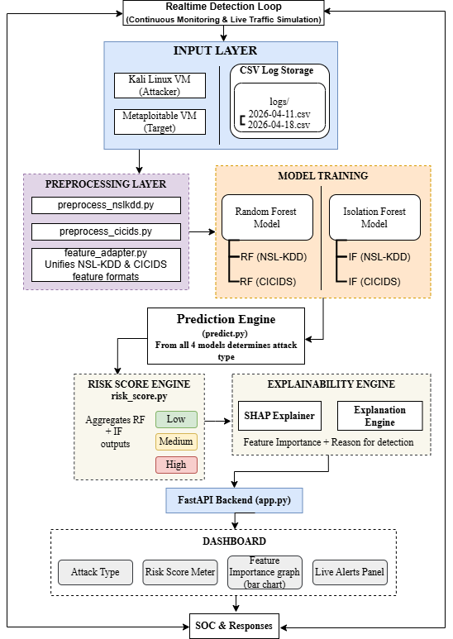

Figure 3.3 System Architecture

Methodology (Approach to solve the problem)

The Explainable AI-Based Intrusion Detection System follows a systematic and modular methodology to detect malicious and anomalous network activities. The approach integrates data collection, preprocessing, machine learning model training, anomaly detection, and a web-based implementation pipeline. The overall workflow is designed for scalability, explainability, and accuracy.

Requirement Analysis
  - Identify the key challenges in intrusion detection — such as unknown attacks, high false positives, and lack of explainability.
  - Define system requirements:
Input: Network traffic data/logs.
Output: Attack classification with risk score.
Constraints: Real-time processing and user-friendly interface.

Data Collection and Preprocessing
  - Collect datasets consisting of normal and attack traffic from reliable sources (e.g., NSL-KDD, CICIDS dataset).
  - Perform data preprocessing:
  - Clean and normalize network traffic features.
  - Encode categorical values using suitable techniques.
  - Handle missing or inconsistent data.
  - Perform feature selection to improve model performance.

Model Selection and Training
  - Utilize machine learning models such as Random Forest for classification of network traffic.
  - Employ anomaly detection models like Isolation Forest for detecting unknown threats.
  - Use supervised learning: Input: Network features Output:
Label (Normal /Attack)

Anomaly Detection Analysis
  - Apply anomaly detection techniques to identify unusual patterns in network traffic.
  - Detect deviations such as:
  - Unusual connection frequency or duration.
  - Abnormal packet sizes or protocol usage
  - Rare or unseen traffic patterns
  - Implement model-based detection to flag suspicious activities.

Explainability Analysis
  - Use SHAP (SHapley Additive Explanations) to interpret model predictions.
  - Identify important features influencing the detection results.
  - Provide insights into why a particular traffic instance is classified as an attack or normal. Combine explainability results with model output for better transparency.

System Integration and Backend Implementation
  - Integrate trained models into a Flask backend for real-time inference.
  - Use APIs to communicate between detection modules and the frontend.
  - Backend flow:
- Accept input data/logs.
- Process and analyze network traffic.
- Generate a response containing prediction, risk score, and explanation.
- Store logs and results if required.

Frontend Development
  - Develop a Develop a responsive dashboard using HTML, CSS, and JavaScript.
  - Key modules:
  - Login/ Login Page: User authentication.
  - Dashboard: Monitor traffic and view alerts.
  - Detection: Display real-time intrusion detection results.
  - Display: Show visual indicators and risk scores for better understanding.

Evaluation and Testing
  - Test the system using both normal and attack traffic samples.
  - Conduct performance and usability testing.
  - Evaluate detection accuracy across different attack types and datasets.

Output Interpretation
  - The system outputs a comprehensive result including:
  - Attack classification (Normal/Intrusion)
  - Risk score
  - Feature importance (SHAP analysis)
  - Detection summary
  - Users receive clear and explainable results for better decision-making.

Deployment and Maintenance
  - Deploy the system locally or on a cloud platform.
  - Maintain the system by updating datasets and retraining models for new attack patterns.

CHAPTER 4

Implementation
The following screenshots illustrate the practical implementation of the Explainable AI-Based Intrusion Detection System (XAI-IDS). The implementation includes the setup of the attacker environment using Kali Linux and the target system using Metasploitable, followed by execution of various network attacks such as DoS, port scanning, and brute-force attacks. The system processes the generated network traffic and provides real-time detection results through an interactive dashboard. Additionally, the dashboard presents risk assessment, attack classification, and SHAP-based feature importance to explain the model’s decision-making, along with activity logs and timeline for continuous monitoring of network behavior.

4.1 Results
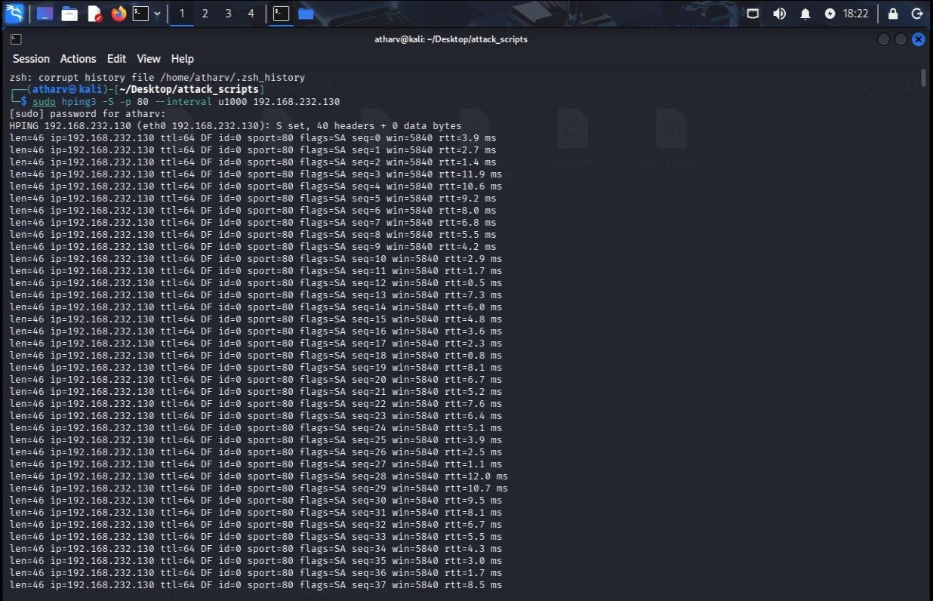

Figure 4.1 Execution of DoS attack using hping3 tool from Kali Linux to generate high-volume network traffic towards the target system.

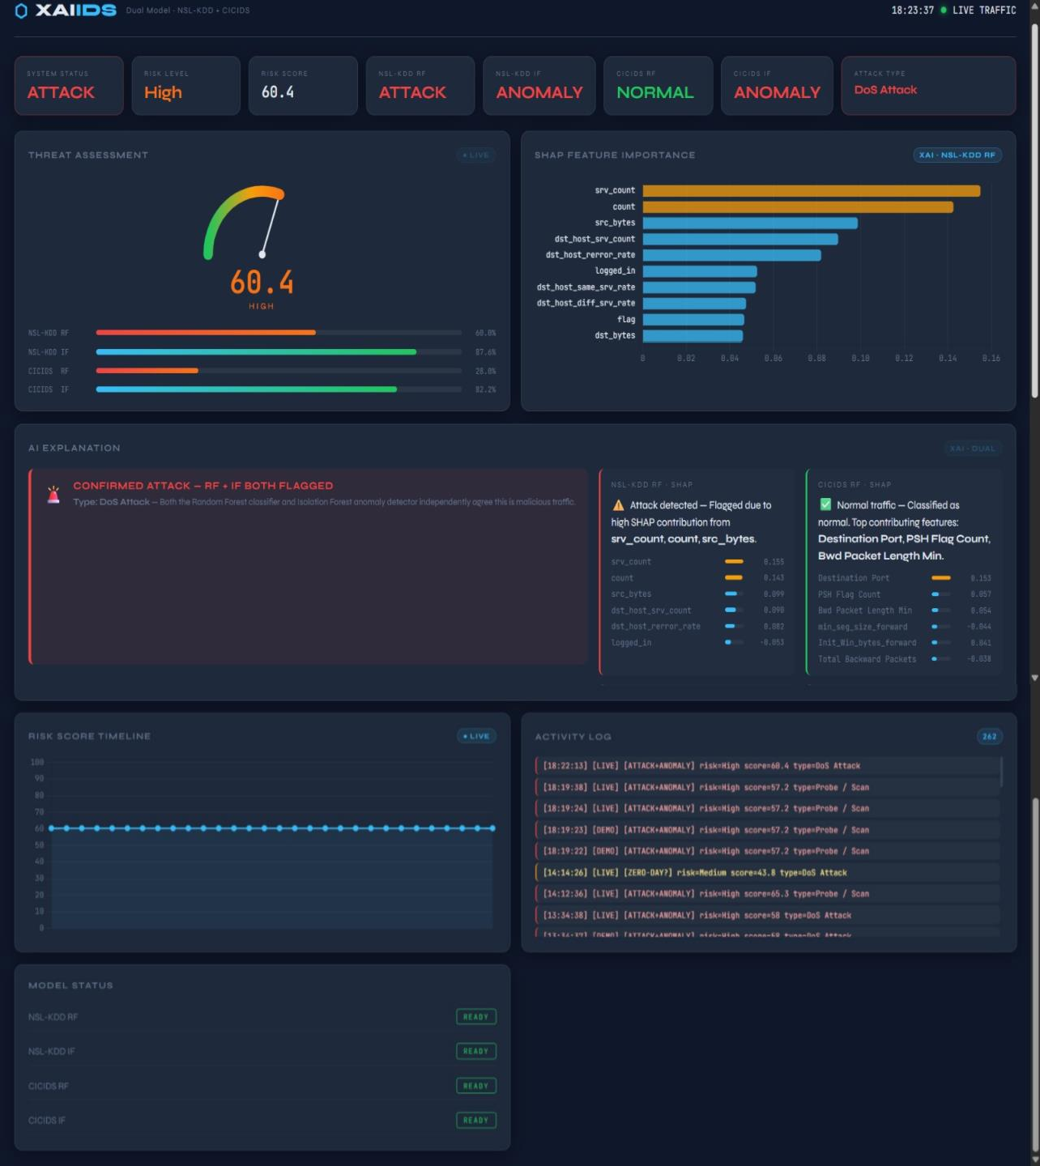

Figure 4.2 XAI-IDS dashboard displaying real-time attack detection, risk assessment, SHAP-based feature importance, along with live risk score timeline and activity logs for continuous monitoring of network intrusions.

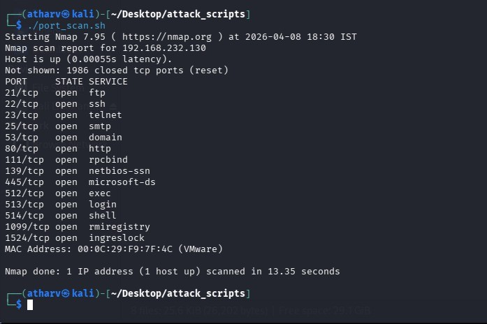
Figure 4.3 Nmap port scanning output identifying multiple open ports and active services on the target Metasploitable system for reconnaissance and vulnerability analysis.
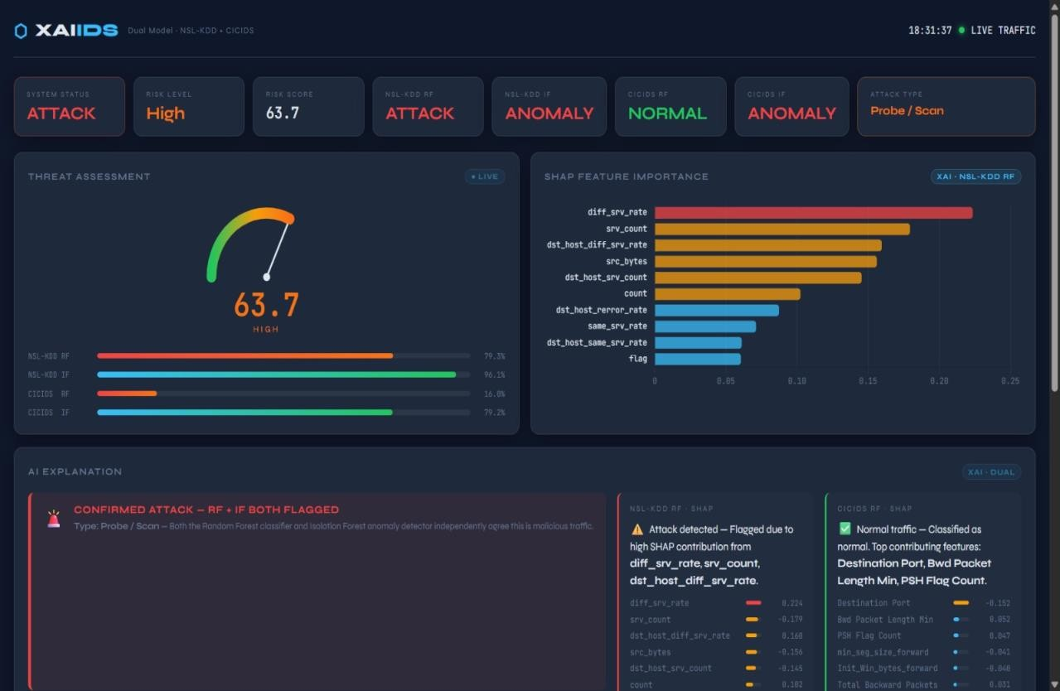

Figure 4.4 XAI-IDS dashboard illustrating detection of probe/scan attack, associated risk level, and SHAP- based feature importance for explainable analysis of network intrusion.
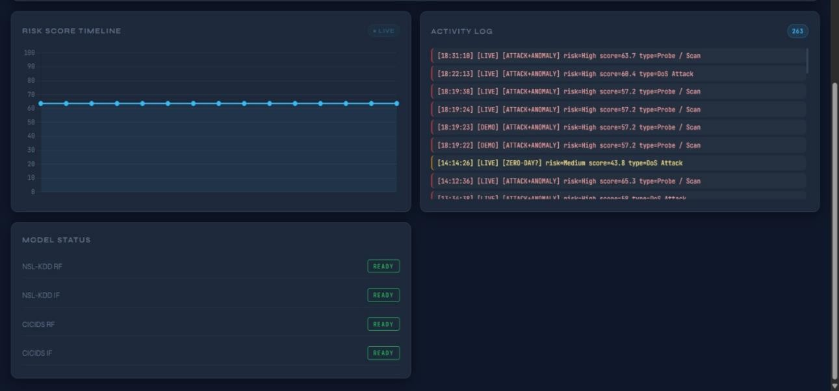
Figure 4.5 XAI-IDS dashboard illustrating real-time risk score timeline and activity logs, enabling continuous monitoring and analysis of detected network intrusions.
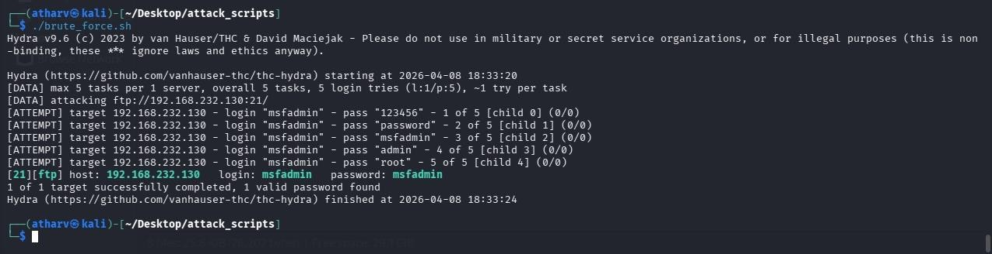
Figure 4.6 Hydra-based brute-force attack demonstrating credential discovery by attempting multiple password combinations on the target system.

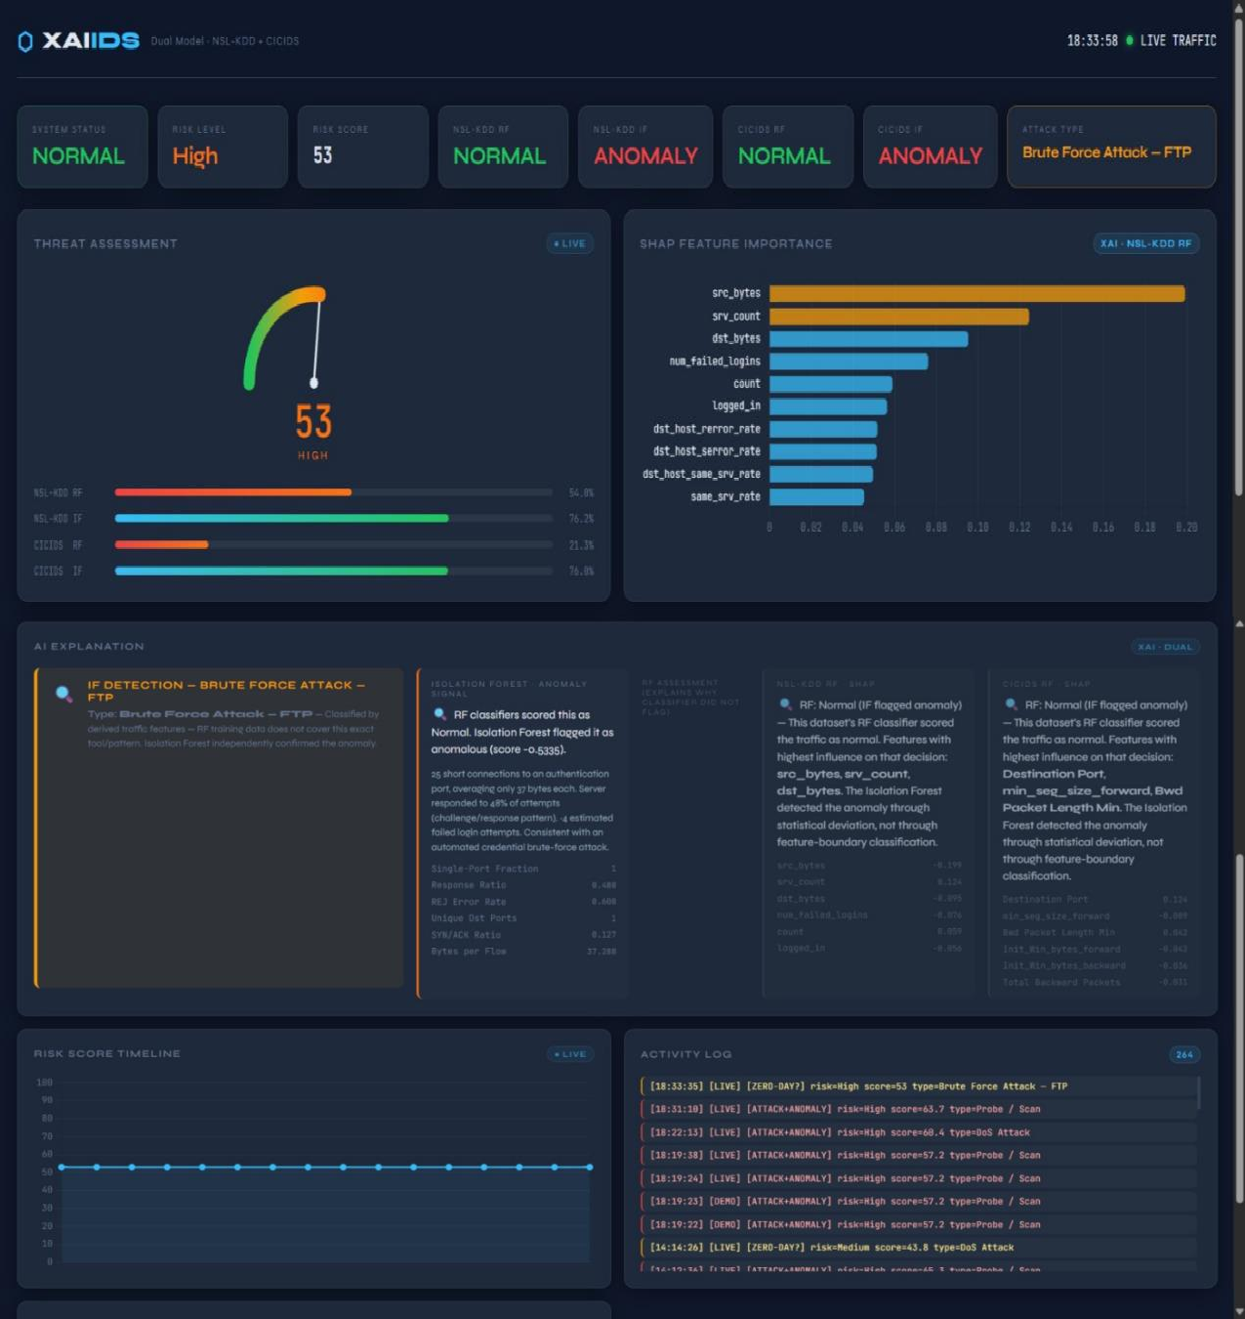

Figure 4.7 XAI-IDS dashboard illustrating detection of brute-force attack (FTP), with associated risk level, SHAP-based feature importance, and detailed AI explanation, along with real-time timeline and activity logs for continuous intrusion monitoring.

CHAPTER 5

Conclusion And Future Outlook

Future Scope:

Improved Model Accuracy:
Train models using larger and more diverse network traffic datasets to improve detection of new and evolving cyberattacks.

Advanced Real-Time Detection:
Enhance the system to handle real-time network traffic using optimized processing techniques for faster and more efficient intrusion detection.

Integration with Security Tools:
Integrate the system with existing cybersecurity platforms such as firewalls and SIEM tools to provide API-based intrusion detection services.

Explainability Enhancement
Improve explainability modules to provide more detailed insights and visualizations for better understanding of model predictions.

Scalable Deployment:
Optimize the backend using cloud or microservices architecture to support large-scale network monitoring and real-time analysis.

Conclusion:
The Explainable AI-Based Intrusion Detection System successfully demonstrates how artificial intelligence and machine learning can be applied to address one of today’s most critical cybersecurity challenges detecting and analyzing malicious network activities. Through the integration of machine learning models, anomaly detection techniques, and explainability analysis, the system provides a comprehensive solution that identifies network intrusions and unusual behavior patterns. The project achieves its objectives by creating a web-based platform that enables users to monitor network traffic, receive detection results, and view supporting insights such as risk scores and feature importance.

The combined approach enhances detection accuracy and makes results more interpretable for users. In addition, the project showcases the potential of combining multiple techniques including classification, anomaly detection, and explainable AI into a unified framework. By doing so, it goes beyond traditional intrusion detection systems and provides a more reliable and transparent solution for modern cybersecurity challenges.

Overall, the developed system validates AI-driven intrusion detection can significantly improve network security, support proactive threat identification.

References

- M. L. Ali, K. Thakur, S. Schmeelk, J. Debello, and D. Dragos, “Deep learning vs. machine learning for intrusion detection in computer networks: A comparative study,” Applied Sciences, vol. 15, no. 4, Art. no. 1903, pp. 1–19, Feb. 2025.

- D. Ajalkar, V. Chavan, and P. Bhosle, “Machine learning based intrusion detection system,” International Journal of Advanced Research in Science, Communication and Technology (IJARSCT), vol. 5, no. 10, pp. 538–540, Apr. 2025.

Acknowledgement

We wish to express our sincere gratitude to Dr. Sanjay U. Bokade, Principal, and Dr. Jyoti Deshmukh, H.O.D., Department of Artificial Intelligence & Data Science, Rajiv Gandhi Institute of Technology, for providing us an opportunity to undertake our project work on “Explainable AI-Based Intrusion Detection System.”

This project bears the imprint of many people. We sincerely thank our project guide Prof. Samrin Pabrekar for her guidance and encouragement throughout the completion of this work.

Finally, we would like to thank our colleagues and friends who helped us in completing the project work successfully.

  - Atharv Patil 641
  - Rudra Pawar 644
  - Darshan Pawar 643
  - Amish Koli 628

